CSA0501-DATABASE MANAGEMENT SYSTEMS
LAB EXPERIMENTS DATE:24/07/2026

EXPERIMENT 9 -- Query with Joins (Equi Join, Inner Join, Outer Join)

AIM:
To perform JOIN operations such as Equi Join, Inner Join, Left Outer Join and Right Outer Join on the Flight Reservation System database.

PROCEDURE:
1. Open MySQL Workbench and select the Flight_Reservation database.
2. Ensure Passenger, Flight, Booking and Payment tables contain sample records.
3. Execute Equi Join, Inner Join, Left Join and Right Join queries.
4. Verify the results of each query.

PROGRAM:

1. Equi Join
SELECT P.Passenger_Name, F.Flight_Name, F.Source, F.Destination
FROM Passenger P, Booking B, Flight F
WHERE P.Passenger_ID=B.Passenger_ID
AND B.Flight_ID=F.Flight_ID;

OUTPUT:
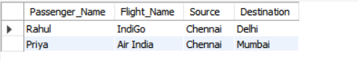

2. Left Outer Join
SELECT P.Passenger_Name, B.Booking_ID, B.Flight_ID
FROM Passenger P
LEFT JOIN Booking B
ON P.Passenger_ID=B.Passenger_ID;
OUTPUT:
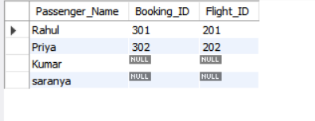

3. Inner Join
SELECT P.Passenger_Name, F.Flight_Name, PM.Amount
FROM Passenger P
INNER JOIN Booking B ON P.Passenger_ID=B.Passenger_ID
INNER JOIN Flight F ON B.Flight_ID=F.Flight_ID
INNER JOIN Payment PM ON B.Booking_ID=PM.Booking_ID;
OUTPUT:
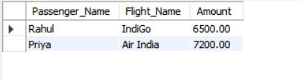

4. Right Outer Join
SELECT P.Passenger_Name, B.Booking_ID, B.Booking_Date
FROM Passenger P
RIGHT JOIN Booking B
ON P.Passenger_ID=B.Passenger_ID;
OUTPUT:
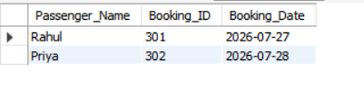

RESULT:
Thus, the records from the Flight Reservation System tables were successfully displayed using Equi Join, Inner Join, Left Outer Join and Right Outer Join.

